**Classification:**

* The classification algorithm is a supervised machine-learning technique used to predict the category of new observations based on a training set.
* In classification, a program learns from the training dataset and then classifies new observations into several classes or groups.
* For example, 0 or 1, spam or not spam, male or female, etc.
* The algorithm that implements the classification is known as **Classifier.**

**Two Types of Classification:**

**1] Binary Classification:**

* If the classification problem has only two possible outcomes, then it is called a binary classification.
* For example, 0 or 1, spam or not spam, etc.

**2] Multi-class Classification:**

* If the classification has more than two possible outcomes, then it is called a multi-class classification.
* For example, the classification of types of crops, and types of diseases.

**Two types of Learners in the Classification problem:**

**1] Lazy learners :**

* The lazy learners first store the training dataset and wait until it receives the test dataset.
* In the lazy learner case, classification is done based on most related data in the training set.
* Lazy learners take less time in training and more time in predictions.
* Example: K-NN, case-based reasoning

**2] Eager Learners:**

* The eager learner develops a classification model based on the training dataset before it receives the testing dataset.
* Eager learners take more time in training and less time in predictions.
* Examples: Naïve Bayes, Decision tree, ANN

**Types of ML classification algorithms:**

**1] Linear Models:**

* Logistic regression
* Support Vector Machine (SVM)

**2] Non-linear models:**

* Decision tree
* K-NN
* Kernel SVM
* Naïve Bayes
* Random forest

**Evaluating a classification model:**

**1] Log loss or cross-entropy:**

* It is used for evaluating the performance of a classification model, whose output is the probability value between 0 and 1.
* For a good binary classification model, the log loss tends to be 0.
* The value of log loss increases if the predicted value deviates from the actual value.
* The lower log loss represents the higher accuracy of the model.

**2] Confusion matrix or error matrix:**

* The confusion matrix provides us with a table/matrix as output and describes the performance of the model.
* The matrix consists of the total number of correct predictions and incorrect predictions.

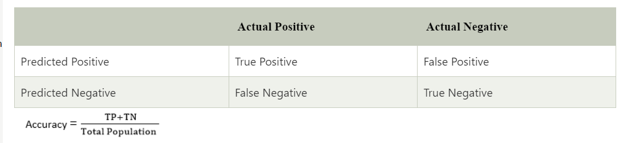

**3] AUC – ROC curve:**

* AUC stands for **Area Under Curve** and ROC stands for **Receiver Operating Characteristics**.
* It is a graph representing the performance of the model at different thresholds.
* To visualize the performance of the multi-class classification model, we use the AUC-ROC curve.
* The AUC-ROC is plotted with TPR on the Y-axis and FPR on the X-axis, where TPR stands for **True Positive Rate** and FPR stands for **False Positive Rate.**